**Groovy Script:**

log.info "SoapUI_Script"

// check the arithmetic operation

int a;

int b;

int c;

//Assign values to variables

a=10;

b=20;

//Add values and assign it to other variable

c=a+b

//Show the result in log

log.info("Result_Add:"+c);

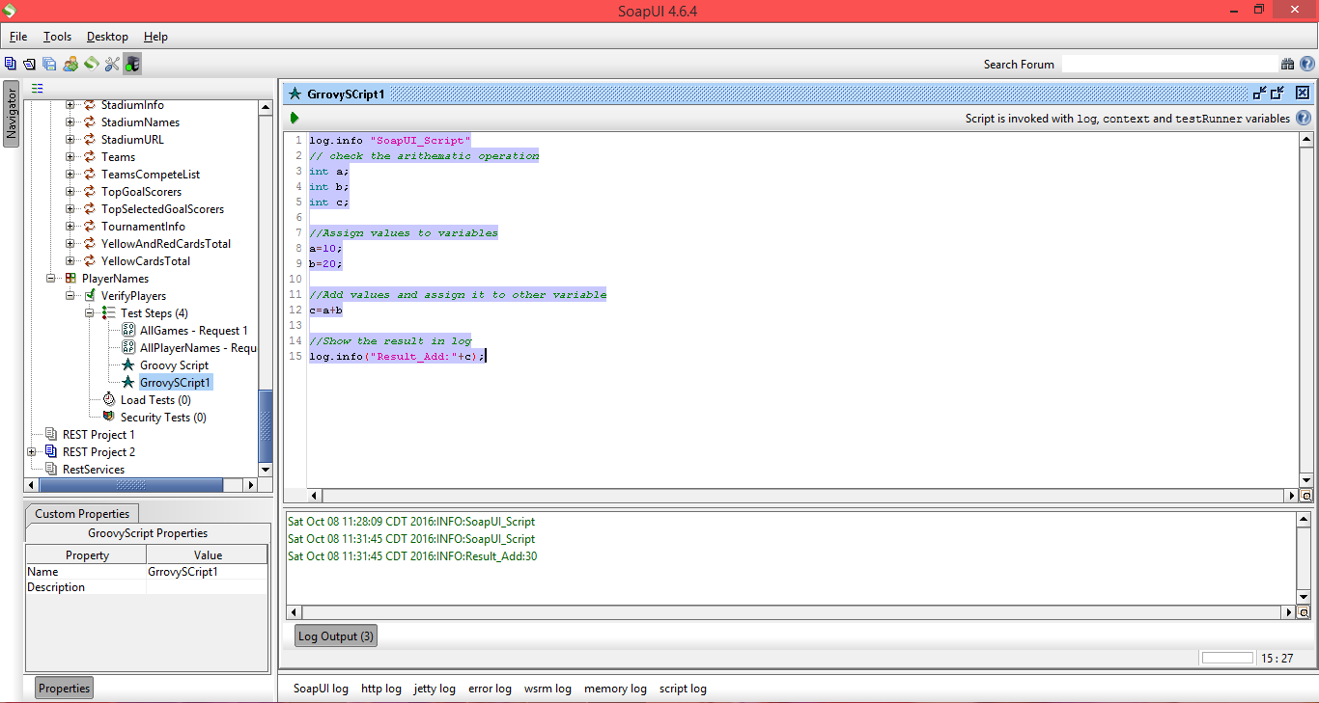

**Arithmetic Operations:**

log.info "SoapUI_Script"

// check the arithmetic operation

int a;

int b;

int c,d,e,f,g;

//Assign values to variables

a=10;

b=20;

//Add values and assign it to other variable

c=a+b;

//Show the result in log

log.info("Result_Add:"+c);

//Subtraction

d=b-a;

log.info("Result_Sub:"+d);

//Multiplication

e=a*b;

log.info("Result_Mul:"+e);

//Division

f=b/a;

log.info("Result_Div:"+f);

//Modulus

g=a%3;

log.info("Result_Mod:"+g);

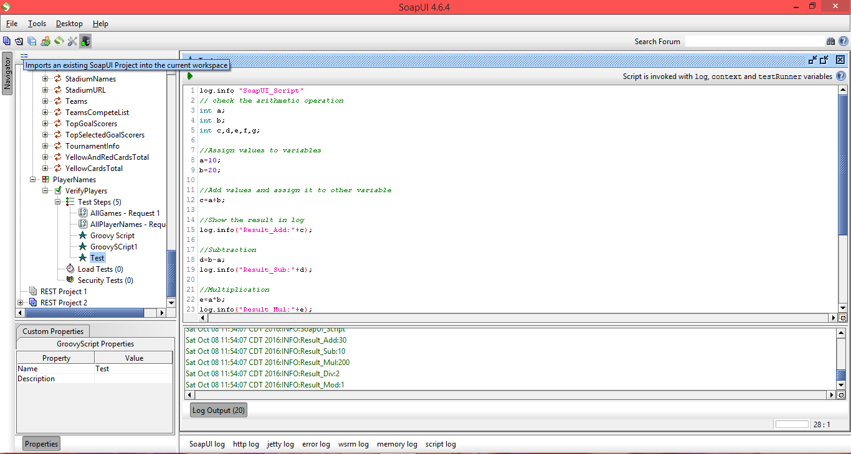

**Output:**

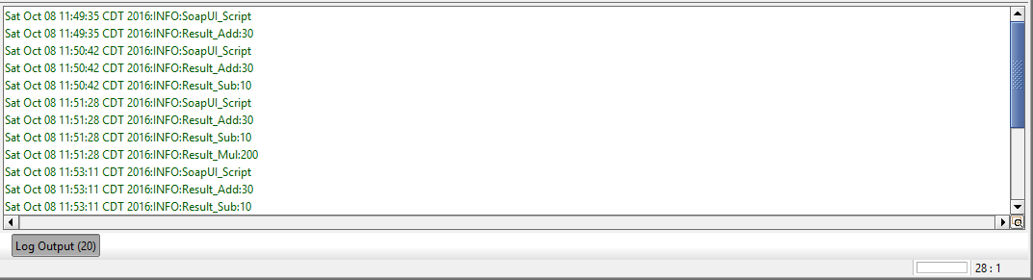

**JSON:**

var family =

{

“Ravi”: {

“name”: “Ravi Shankar”,

“age”: “25”,

“gender”: “Male”

},

“Prema”: {

“name”: “Prema Latha”,

“age”: “22”,

“gender”: “Female”

}

}

1. document.write(family.Ravi.name);
2. document.write(family.Prema.age);
3. document.write(family.Ravi.gender);

**OUTPUT:**

1. Ravi Shankar
2. 22
3. Male

**XML:**

1. <?xml version=”1.0?>

<note>

<to>Ravi</to>

<from>Prema</from>

<heading>Reminder</heading>

<body>Do your stuff on time!</body>

</note>

1. <?xml version=”1.0”?>

<note date= 10/12/89>

<to>Prema</to>

<from>Ravi</from>

<heading>Reminder</heading>

<body>Do your stuff on time!</body>

</note>